Use case of NMR spectrometry in Virtual Laboratory

Abstract
This document describes use case scenario in the field of Nuclear magnetic resonance (NMR) spectroscopy. The use case has been implemented in the Virtual Laboratory project. Varian spectrometer has been deployed in the VLab environment as a pilot scientific device. Moreover, thanks to the VLab architecture it is possible to conduct and control NMR experiments remotely, process data and finally visualize them.

Table of Contents
1. Summary 3
2. Customers 3
3. Scenarios 3
4. Involved resources 5
5. Functional requirements 6
6. Non-functional requirements 15
6.1. Security considerations 15
7. Related work / Experience in the field 15
7.1. Experience in the field 18
8. Use case situation analysis 19
9. Contact Information 23
References 24

Summary
This document describes use case scenario in the field of Nuclear magnetic resonance (NMR) spectroscopy. The use case has been implemented in the Virtual Laboratory project. Varian spectrometer has been deployed in the VLab environment as a pilot scientific device. Moreover, thanks to the VLab architecture it is possible to conduct and control NMR experiments remotely, process data and finally visualize them. Nuclear magnetic resonance spectroscopy, most commonly known as NMR spectroscopy, is the name given to a technique which exploits the magnetic properties of certain nuclei. This phenomenon and its origins are detailed in a separate section on nuclear magnetic resonance.
NMR spectroscopy applications area is very wide and contains medicine, chemistry, non-destructive testing, data acquisition in petroleum industry, process controlling, Earth’s field NMR, magnetometers

Customers
Primary Actor:
The scientist interested in examining some kind of material with the use of NMR spectroscopy.

Secondary actors:
NMR Spectrometer operators (sometimes scientist and operator can be the same person).

Stakeholders and interests:
The scientist, spectrometer operator(s). If the experiment is conducted with use of third party sample material - the owner of the sample is also in this group. In many cases the scientist and equipment operator is the same person and can use spectrometer for his own scientific purposes. Operator can also play a utility role for an external person who submits the sample material to be examined, used in NMR experiment.

Scenarios
Preconditions:
NMR Spectrometer and its controlling computer must be up and ready. Sample material must be prepared for experiment: mixed with appropriate solvent and inserted into the spectrometer.

Minimal guarantee:
The spectrum of the examined sample must be received as output from the spectrometer.

Success guarantee:
The spectrum of the examined sample is satisfied in the terms of its parameters that allow to answer the questions set by scientist before the experiment.

Main success scenario:
- Log onto the computer controlling the spectrometer.
- Lock on the sample in the spectrometer.
- Make the shimming of the sample (calibration process).
- Acquire spectrum for the sample with the required parameters, store it in the local data sink if needed
- Log off from the spectrometer controlling computer.

Extensions:
Situations that can result in bad (corrupted in some way) spectrum result. The causes of bad result (spectrum not good enough for the user) can be as follow:

2a. Sample degradation - sample can be applicable to perform the experiment only for some limited time. Outdated sample can cause poor spectrum result.
2a1. New experiment material must be delivered

2b. Sample was not prepared properly - NMR sample preparation in short means dissolving it in a proper solvent. Errors made during this process can cause wrong experiment result.
2b1. Sample should be prepared again if there is enough of initial material to do it.
2b2. The new experiment material must be delivered

3a. Spectrometer calibration - the equipment should be properly tuned up just before gathering the results. Errors can cause wrong spectrum as a result. Sometimes it can be noticed during the experiment duration and there is no need for waiting until its end - usually the experiment can be interrupted if partial results are not correct (not fitting user’s expectations)
3a1. Calibration process must be repeated and experiment must be restarted.

4a. Unstable temperature. The room that contains the spectrometer equipment must ensure very stable temperature parameters. If there are temperature fluctuations during the experiment it will cause noise in the experiment result.
4a1. The spectrometer environment must have stabilized temperature. Experiment must be restarted after reaching this condition.

4b. Similar situation like in previous point but relevant to magnetic fields. Major changes in the magnetic field of the close spectrometer environment will cause wrong experiment result.
4b1. The spectrometer environment must have stabilized magnetic field. Experiment must be restarted after reaching this condition.

4c. Spectrometer technical failure can cause total lack of result. There are many areas where such problem may occur. It can be electrical failure in the electronic part of spectrometer controlling devices, software/hardware problem in spectrometer's controlling computer, technical problems with spectrometer pneumatic, air-conditioning and other installations.
4c1. Experiment should be restarted after maintaining the equipment technical failure.

Involved resources
In the Virtual laboratory of NMR spectroscopy there are several types of resources to be distinguished:
- Laboratory Devices – laboratory apparatus and software for experiment execution (in scope of NMR it can be Varian 300MHz, Bruker 600MHz)
- Computational Servers – software for data pre-processing and post-processing. Applications for data processing can be run on grid resources using existing grid middleware such as Globus toolkit (versions 4.0.3 or 4.0.4) and GRMS Gridge Resource Monitoring Service (GRMS) to submit and execute computational tasks on the grid
- Visualization Servers – visualization software used for experiment results presentation (e.g.VMD application).
- Storage element/Science library – stores experiment’s data and allows other users sharing the works results

The resources can be geographically distributed inside the laboratory the user belongs to. There is a multiple user access to the VLab server (with varying levels of access; laboratory administrator, device operator, user).
NMR spectrometer – equipment consists of the following components:
- magnet with additional supporting equipment (like cryogenic installation, air filtering system, samples handling system, etc. – full list of equipment depends on particular implementation);
- steering, computer unit that controls magnet, provides data acquisition from it;
- interface: controlling software that allow to adjusting and monitoring NMR spectrometer parameters during the experiment duration.

Sample: material that will be examined in NMR spectrometer. Usually it has to be properly prepared before the experiment - mixed with appropriate solvent and inserted into the spectrometer (or samples handling system that can automatically manage inserting/extracting process with more than one sample).

Interface – software that allows remote access to the equipment: software system that allows remote users to perform full path of NMR experiment with use of spectrometer. It can contain following modules (on the example of VLAB system developed in PSNC):
- scenario builder - allows to predefine steps of the experiment, parameters, conditions (triggers and filters), main points in its path of execution;
- monitoring module – allows to watch experiments steps, status, progress;
- interactive sessions application – in the case of need allows remote user directly access the spectrometer controlling software or collected data post-processing applications working on remote systems;
- data library – storage system that allows to collect, manage and share results of experiments

Functional requirements
The functional requirements were divided into two groups. First group covers the general requirements for a remote instrumentation system, its basic functionality, and the second group reflects the specific requirements of NMR spectroscopy and remote access to NMR spectrometer. The requirements were collected from scientists working in Laboratory of Structural Chemistry of Nucleic Acids of Institute of Bioorganic Chemistry, Polish Academy of Sciences, Poznan, Poland.
The requirements are presented in the form of tables, each requirement consists of the following elements:
- requirement number and name
- actor(s): the people which use the functionality, or are affected by the function
- condition: determining any additional conditions that have to be met in order to perform a given function
- input: what is given on a function input
- output: what is produced on a function output
- side effect: any other effects caused in the system when performing such function

- Generic requirements

- Logging into the system
Actor | All system users
Condition | Login and password correct
Input | Login name + password
Output | Welcome screen displayed
Side effect | After login the user role is determined and proper modules are loaded, ensuring required user interface and functionality.

- Displaying the usage statistics
Actor | System administrator, end user
Condition
Input | The type of the required report (for the whole system or for a specific virtual laboratory or user) e.g.:  - system usage by each laboratory  - workload generated by each laboratory  - number of task submitted by laboratory  - usage of scientific devices  - usage of computational systems
Output | Accounting data displayed
Side effect

- Setting the maximum limits for scientific devices and computational systems
Actor | System administrator
Condition
Input | Id of the device or computing system, new value of usage limit (per day, week, month etc), for every laboratory or individual user
Output
Side effect | Limit changed and stored in system database

- User rights management
Actor | System administrator
Condition
Input | User id, new user priority values, new status of the rights:  - access to specific scientific devices  - access to the data repository  - access to the computational resources  - access to communication interfaces
Output
Side effect | User profile updated

- Monitoring of task queue for a laboratory
Actor | System administrator, end user
Condition
Input | User id, laboratory id, device id
Output | The list of tasks queued by the members of a given laboratory, with the possibility of viewing the task details:  - date and time the task was scheduled  - estimated time of task execution and completion  - task priority  - task description
Side effect

- Monitoring of task queue for a laboratory
Actor | Device administrator
Condition
Input | The time interval for each day of week, when the scientific device is available in the virtual laboratory
Output
Side effect | Device profile updated.

- Monitoring of task queue for a laboratory
Actor | Device administrator
Condition
Input | The time interval for each day of week, when the scientific device administrator is available for device monitoring and operation
Output
Side effect | Device profile updated.

- Communication between laboratory members
Actor | All system users
Condition | Communication channel enabled
Input | Users id, the chosen communication method
Output | Communication interface displayed
Side effect

- Confirmation of device readiness for experiment
Actor | Device operator
Condition | Experiment for a given task id ready and can be performed on the device
Input | Task id from the device tasks queue
Output | Communication interface displayed
Side effect | Tasks status changed, tasks owner notified

- Aborting the experiment
Actor | Device operator, End user
Condition | Experiment in progress
Input | Request to interrupt experiment
Output | User notification and reasons for interruption
Side effect | Experiment state and collected data stored for further use

- Access management to the scientific devices and computational systems (incl. software)
Actor | System administrator
Condition | Given resources available in the system, working and configured
Input | Users id, the resource id, laboratory id, new access status (granted, not granted, suspended)
Output
Side effect | User and appropriate resources profiles updated

- Setting the user availability hours
Actor | End user
Condition
Input | The time interval for each day of week, when the end user is available for performing the interactive experiments
Output
Side effect | User profile updated - required for proper task scheduling

- Displaying the device user interface
Actor | End user
Condition | Device ready for experiment, task confirmed by device operator
Input
Output | User interface to the device allowing the user to perform experiment from a remote location
Side effect

- Overview of the experiment progress
Actor | End user
Condition | Experiment in progress
Input | The request for displaying the current experiment results
Output | The visualization of acquired data
Side effect

- Ending the experiment – storing the results
Actor | End user
Condition | Experiment finished normally
Input | Experiment results
Output | Set of output files stored in data repository
Side effect | Files attributes set to read/write for owner and read for owner's laboratory group

- Submitting the experiments in batch mode
Actor | End user
Condition | User logged in the system, lock and shim done manually in advance, experiments don't require user's intervention
Input | Batch file with definition of series of experiments
Output | Set of output files stored in data repository
Side effect | Files attributes set to read/write for owner and read for owner's laboratory group

- Browsing the list of performed experiments
Actor | End user
Condition | Queried user belongs to the same laboratory group
Input | User id
Output | The list of tasks (experiments) submitted by a given user
Side effect

- Interactive post processing of acquired data
Actor | End user
Condition | User has read rights to the data files
Input | Visualization of input data, with all parameters necessary for performing data analysis and evaluation
Output | Graphical representation of data, modified according to parameters changes in real time
Side effect

- Submitting computational jobs
Actor | End user
Condition | User has an access rights to proper computing systems (software)
Input | Experiment results
Output | Information from job scheduler
Side effect | Task submitted to the appropriate queue system

- Monitoring of computational jobs
Actor | End user
Condition | User is the task owner
Input | Task id
Output | Current tasks status
Side effect

- Specific requirements of NMR spectroscopy

- Monitoring of task queue for NMR spectrometer
Actor | End users, system administrator, device operator
Condition
Input
Output | The list of tasks queued by the members of a given laboratory, with the possibility of viewing the task details:  - experiment type  - sample information  - sample id  - sample form (solid, liquid, etc.)  - sample formula  - sample properties  - type of probe used for experiment  - the temperature range  - the nucleus type  - estimated experiment time  - experiment start time
Side effect

- Definition of additional scheduling criteria for scientific device – NMR spectrometer
Actor | System administrator, device operator
Condition
Input | List of parameters defining the scheduling order of experiments on NMR spectrometer  - type of required probe  - required filter types  - temperature range  - task priority
Output
Side effect | Tasks rescheduled according to given criteria

- Definition of additional scheduling criteria for scientific device – NMR spectrometer
Actor | System administrator, device operator
Condition
Input | List of parameters defining the scheduling order of experiments on NMR spectrometer  - type of required probe  - required filter types  - temperature range  - task priority
Output
Side effect | Tasks rescheduled according to given criteria

- Temperature control of the sample used in experiment
Actor | Device operator
Condition | Experiment in progress
Input
Output | Current sample temperature, critical values
Side effect | Visual warnings when the critical values are exceeded

- Submitting interactive jobs on NMR spectrometer
Actor | End user
Condition | Device is available for a given user, input data validated and within operational limits
Input | Experiment information:  - sample id (required for sample identification)  - sample form (solid,liquid etc.)  - sample formula  - sample properties (toxic, radioactive etc)  - additional sample information  - type of required NMR probe, required temperature range,nucleus type, pulse sequence  - experiment time (estimated)  - required start time  - device selection criteria (priorities, deadline, required precision) – if more than one device is available for experiment
Output | Information on when the task was scheduled, what (if any) device has been selected
Side effect | Device queue updated with a new task, according to defined queue parameters and scheduling criteria

- Changing the pulse sequence
Actor | End user
Condition
Input | The id or name of a new pulse sequence
Output | Parameter list for a given pulse sequence, with default values
Side effect | New pulse sequence selected, with possibility of changing default values

- Changing the initial parameters values
Actor | End user
Condition | Parameter within accepted range
Input | The new value for a given parameter of selected pulse sequence
Output | Parameter list for a given pulse sequence, with default values
Side effect | Parameter value updated

- Setting the lock and shim for NMR experiments (acqi window)
Actor | End user
Condition | Parameter within accepted range
Input
Output | Interactive window with the possibility of setting lock and shim in the real time
Side effect

- Changing probe temperature
Actor | End user
Condition
Input | New value for probe temperature
Output | Warning about possible consequences of changing probe temperature
Side effect | New sample temperature set

- Starting the NMR experiment
Actor | End user
Condition | Lock and shim set
Input | Pulse sequence and specific experiment parameters
Output | Experiment results in the form of binary file (FID)
Side effect

Non-functional requirements

Security considerations
In case of NMR spectroscopy we are dealing with very sophisticated and expensive scientific devices. Therefore, it is very important to ensure that only the authorised people have the possibility to connect and gain the control of the NMR spectrometer. Also, the locally present device operator, must have a possibility to closely monitor experiment progress and all its parameters, as it is possible to damage the spectrometer by giving wrong or inappropriate user input. The device operator must have the rights to abort the experiment at any time, grant and deny an access to a specific users or all users at the same time.
Another important aspect is to provide the high security level of produced experiment output, as in most cases scientists perform very important, often confidential, research. Users have to have a full control on where and how their scientific output is stored, with the possibility of granting/denying the access to other members of their organization or in general, other remote instrumentation system users.

Related work / Experience in the field
The necessity of using unique and/or expensive equipment, which is often locally unavailable, as well as of broad international cooperation are key issues for the success of the great number of science or industry ventures. The opportunity of accessing sophisticated equipment plays a significant role in the equality of opportunity and the unification of communities.
Thus the development and spreading of Remote Instrumentation techniques and technologies that allow virtualized, remote and shared access to industrial or scientific instruments open up new opportunities for European industry, science and business.
Perhaps the ideal form of use of remote instruments is remote operation, where full control is in the hands of the remote user. However, due to the complexity and high capital cost of some of the equipment considered in this project, remote operation by external researchers can be a little bit away in the future. For example, at least initially, electron microscopes and large-scale telescopes will not be open for remote operation by users due to the high risk that this represents for the equipment. However, the simpler and safer mode of remote assisted use can be introduced in a short period of time. Remote assisted use permits remote experts to handle the equipment and interactively visualize the results, through the mediation of an on-site operator, possibly a junior member of the remote team. This capability will also be used to offer practical training courses in instrument operation to remote user sites.
Remote assisted use will substantially reduce the human and financial cost of using remote instruments, as it provides the possibility of sharing the results live with other researchers at their home institution or even at other institutions, making better use of senior researchers' time. A practical example can be provided by remotely assisted electron microscopy, where industrial clients will be able to reduce costs and facilitate live data analysis and test optimization via remote in-company experts participation in the analysis.
In the case of a synchrotron light source, remote assisted use would also provide a more efficient way to take advantage of the available unique techniques. A synchrotron source usually works 24h/day, and the possibility of accessing the experiment from other sites would help to improve control and accompaniment of experiments. It could also be explored to offer preliminary training in the operation of beamlines, before users visit the laboratory, and in support wherever there is such a need. Since synchrotron experiments usually require a simultaneous data analysis, remote assisted use would allow live sharing and discussion of the results with other members of the group who would not need to travel to participate in the experiments. Similar considerations also apply to optical and radio telescopes, which are very often located in places which are time-consuming and expensive to reach, and many observatories are also beginning to recognize the advantages and embrace the concept of remote assisted use.
Another alternative form of using information and communications technologies to make more effective use of expensive remote instruments is to archive scientific data resulting from observations in places not necessarily close to where these are generated, and ensuring efficient access to these archives. Good examples of this are IVOA and LBA. The International Virtual Observatory Alliance (IVOA) - http://www.ivoa.net/ - is a worldwide effort for the integrated use of numerous large data archives as an efficient and innovative tool for astronomical research. The Large Scale Biosphere-Atmosphere Experiment in Amazonia (LBA) - http://lba.cptec.inpe.br/lba/site/ - is an international research initiative led by Brazil. LBA is designed to create new knowledge needed to understand the climatological, ecological, biogeochemical, and hydrological functioning of the Amazon region, the impact of land use change on these functions, and the interactions between the Amazon region and the Earth system. LBA observational data is being archived at the National Institute for Space Studies (INPE) in Cachoeira Paulista, SP, Brazil, and also at mirror sites in the United States and Germany. Such efforts also depend crucially on computing and communications infrastructure.
Grid research has focused on the marshalling of computation and data, and their interactions at hubs of analysis and synthesis. As the technology for computational and data grids has matured, however, increasing attention is being directed towards the actual sources of data: the instruments and sensors.
Scientific instruments and sensors provide raw observations used to develop, falsify, and verify scientific theories; and thus drive scientific progress. The acquisition of data produced by such apparatus is not a straightforward procedure, and often interacts profoundly with interpretation and analysis, whether by a human or machine. Ignoring this interaction can lead to inefficient use of computational and human resources. The additional introduction of virtual instruments for in-silico experiments leads to even higher levels of flexibility, but also complexity to be tackled.
The above considerations suggest the need to push the Grid to the points where data is collected, and to the point where scientists use data; and thus create an end-to-end (stimulus-to-output) Grid environment for scientific activity. Instruments and sensors are qualitatively distinct from computation and data, however, and thus impose some unique challenges and issues to current Grid technologies. Expectations from the underlying infrastructure and the existing protocols are higher, and an understanding of many different disciplines is required to integrate all the necessary bits and produce solid footing for complex systems such as instrumentation grids.
Various international projects already tried to target at least some of the aspects involved in system-level science and instrumentation grids.
The GRIDCC (IST-511382) (Grid-enabled Remote Instrumentation with Distributed Control and Computation) project extends the Grid to include access to and control of distributed instrumentation. The goal of the GRIDCC project is to build a widely distributed system that is able to remotely control and monitor complex instrumentation integrated with the existing Grid infrastructure. This project recently demonstrated the possibility to implement feedback loops through the Grid, involving instruments, storage and computing resources and a distributed team interacting though a virtual control room. GRIDCC has essentially produced a representation of instruments for the Grid through its Instrument Element abstraction. Additional facilities are built around the instrument element to take advantage of it and its interaction with the rest of the Grid, enabling complex web service-based workflows, Quality of Service estimations based on historical data and resource reservations, and a Multipurpose Collaborative Environment to offer an interface to all these facilities.
The INT.EU.GRID (IST-031857) project is deploying and operating an interoperable production-level e-Infrastructure for demanding parallel applications, which allow the expert to interactively steer the simulation. The results achieved through such interactive simulations will impact the daily work of researchers and allow more efficient usage of the available computational resources. An important challenge of the project is to change the way the researchers can use this e-Infrastructure, exploiting the interactivity and collaboration possibilities. Therefore, interactivity on the Grid is the main focus of the project. While guaranteeing interoperability with existing large e-Infrastructures like EGEE, by providing basic common middleware services, the initiative exploits the expertise generated by the EU CrossGrid project to provide researchers with interactive and simultaneous access to large distributed facilities through a friendly interface with powerful visualization.
RINGrid (Remote Instrumentation in Next generation Grids) is identifying instruments and user communities, defining requirements and trying to find synergies between remote instrumentation and next-generation high-speed communications networks and grid infrastructures. Project results will be disseminated to scientific, industrial and business groups of users, to increase awareness of the benefits of using next-generation Remote Instrumentation Systems, which are essential for promoting egalitarian access to the European e-Infrastructure opportunities. RINGrid is providing a better understanding of the user-community requirements, extending on many different disciplines and examining what networking and middleware functionality is deemed necessary for instrumentation grids.
The g-Eclipse project is creating the framework that may serve as the future workbench, bringing new applications, new users and new Grid resource providers together in the European Research Area. The g-Eclipse project provides an integrated Grid environment for Grid users, Grid operators and Grid developers. The g-Eclipse tool is built on top of the open source Eclipse framework, and brings together expertise from the academic Grid community and from the Eclipse community. The latter has a deep commercial penetration in the Information Technology industry. g-Eclipse integrates the Grid and allows user-friendly access to Grid resources, by making the complexity of the Grid invisible. The architecture of the g-Eclipse framework is made for reuse and extension to allow for easy adaptation by new Grid applications. In addition the Eclipse framework proved its suitability for remote instrumentation already in the past, i.e. when NASA launched a new space system.
But this is of course not a European-only effort. The NEESgrid project links earthquake researchers across the U.S. with leading-edge computing resources and research equipment, allowing collaborative teams (including remote participants) to plan, perform, and publish their experiments. Through NEESgrid software, researchers can: perform tele-observation and tele-operation of experiments, access computational resources and open-source interactive analytical tools.
CIMA, the Common Instrument Middleware Architecture of the Instrument-Middleware Project in the U.S. is following an approach different than the one of GRIDCC to achieve similar goals. CIMA is investing in semantic descriptions of instruments, which can be consumed by interested peers to generate dynamic clients and invoke their functionality according to those descriptions. Although CIMA goes for extensibility and manages well in this regard, it is harder to be abstract enough and apply this methodology in highly complex equipment to describe their very fine-grained functionality.

Experience in the field
The Virtual Laboratory system is developed in Poznań Supercomputing and Networking System in collaboration with the Institute of Bioorganic Chemistry and the Radioastronomy Department of Nicolaus Copernicus University since 2002. The main goal of the VLab is to create a framework for building many different types of laboratory. Another purpose is defining all accessible remote facilities treated as simple resources in the Grid infrastructure. It is possible thanks to the VLab broker which is connected with the Grid resource broker. Each job directed to the real laboratory facilities is treated as any other Grid task. Another issue concerns a conception of dynamic measurement scenarios. It allows defining the process of experiment in any way, from pre-processing, through executing the experiment, to the post-processing and visualization tasks. Users are also allowed to add their own module as a part of the scenario. The Virtual Laboratory is not only a set of mechanisms to submit, monitor and execute jobs. It is also a possibility to give access to the resources of the digital library, communication, and e-Learning systems. VLAB was a part of the "High Performance Computations and Visualisation for Virtual Laboratory Purposes with the Usage of SGI Cluster" project which is based on the State Committee for Scientific Research decision (decision number 03282/C.T11-6/2002 of December 9th 2002) on participation in the funding of the research, development and implementation. The scope of this research (project) cover a pilot project of a Virtual NMR Laboratory. This laboratory relied on the resources of the Institute of Bioorganic Chemistry, PAS (Bruker 600MHz and Varian 300 spectrometers). The methods of high resolution homo- and heteronuclear NMR spectroscopy, which are used in the Laboratory of Structural Chemistry of Nucleic Acids, allow to determine the 3-dimensional structure of biomolecules in a solution. The concept of the Virtual Laboratory has been elaborated to facilitate the research in this domain, which is important to the biopolymers chemistry, molecular biology, biomedicine, and biotechnology.
The experience gained during design and implementation of the VLab project is currently being used in international projects: RINGrid (http://www.ringrid.eu/), EXPReS project (http://www.expres-eu.org) and DORII (http://www.dorii.eu).
The main objectives of the RINGrid project include: the systematic identification of instruments and corresponding user communities, a definition of their requirements as well as careful analysis of the synergy between Remote Instrumentation and next-generation high-speed communications networks and grid infrastructure as a basis for the definition of recommendations for designing next-generation Remote Instrumentation Services. The dissemination of project results among scientific, industrial and business groups of users will promote egalitarian access to the European e-Infrastructure and increase awareness of benefits from using next-generation Remote Instrumentation Systems.
The overall objective of EXPReS is to create a production-level real-time, electronic VLBI, or e-VLBI, service in which the radio telescopes are reliably connected to the central supercomputer at JIVE in the Netherlands via a high-speed optical-fibre communication network.
The DORII project aims to deploy e-Infrastructure for new scientific communities, where on the one hand the ICT technology is still not present at the appropriate level, but on the other hand it is demanded to empower its daily work. We deal with a group of scientific users, and this is a reference for DORII, with experimental equipment and instrumentation that are not integrated or integrated only partially with the European infrastructure.

Use case situation analysis

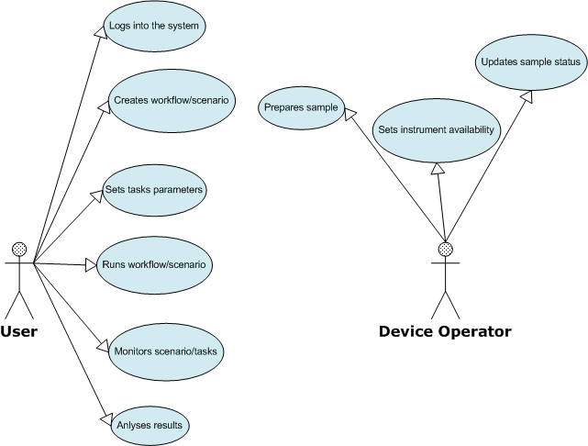
Figure 1. VLab use case diagram

VLab modules activity diagram (Figure 2) presents steering flow between modules in VLab.

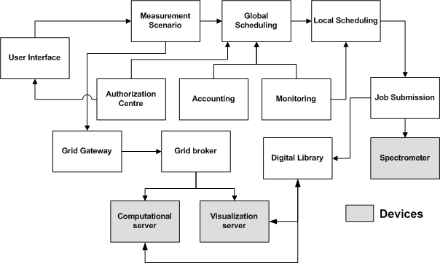
Figure 2. VLab modules activity diagram

Experiments executed in the NMR VLab system consist of many stages. Usually it looks as follows: a scientist prepares a sample and/or input data (e.g. parameters) which will be measured/computed. Next she/he uses laboratory devices to achieve data which are the processed by a specialized software. Processing can include the visualization stage if it is needed to assess the results.

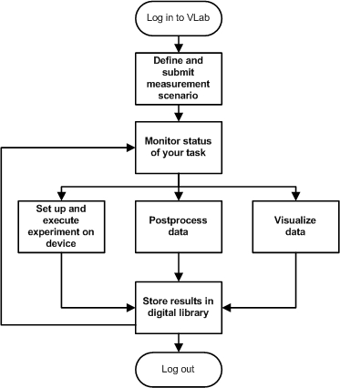
Figure 3. General user activity diagram in VLab

In case of undesirable results some measurement stages should be repeated. At each stage the scientist decides which way the research should go next. As we can see, the experiment process execution may consist of very similar stages in many scientific disciplines (laboratories). The given experimental process is often executed recurrently by some parameters modification. Obviously, the presented scenario is typical but we realize that scholars can have more sophisticated needs.
The conception of the dynamic measurement scenarios in VLab system allows defining the process of an experiment in any way, from pre-processing, through executing the experiment, to the post-processing and visualization tasks. Defining the measurement scenario allows to spare a lot of time during computation. The user does not have to wait for the end of a given process stage to submit another one. It is made automatically.
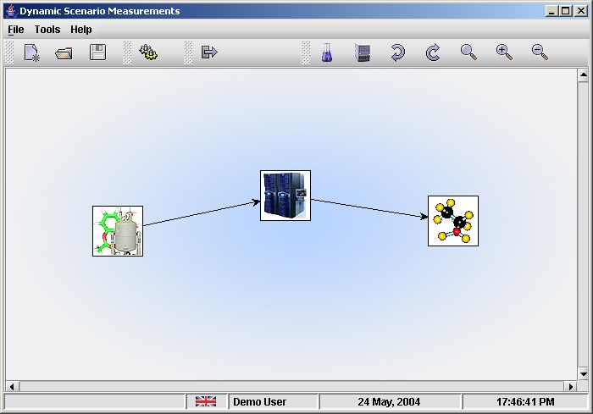
Figure 4. Defining 3-element measurement scenario in NMR VLab

Below we present activity diagram for NMR Virtual Laboratory for 3-stage measurement scenario which consists of the following phases:
- execution of experiment on spectrometer (Varian 300 MHZ),
- performing post-processing with Felix application,
- visualization using VMD application – final stage of scenario.

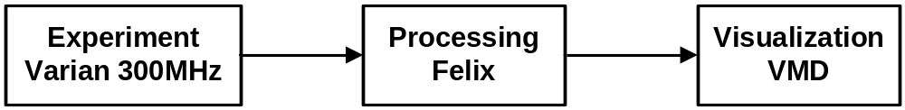

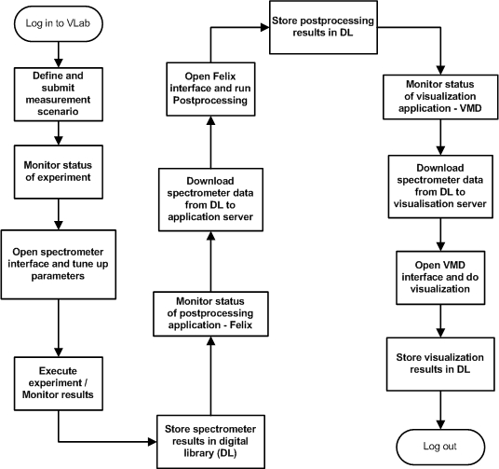
Figure 5. Diagram of activity for 3-element (Varian→Felix→VMD) scenario

A digital library is seen a storage system where all (also intermediate) results/data are stored. Moreover, it allows users to share experiment results and bibliography concerning a given scientific discipline.

References

Lawenda M., Meyer N., Rajtar T., Okon M., Stoklosa D., Kaliszan D., Kupczyk M., Stroinski M, Workflow with Dynamic Measurement Scenarios in the Virtual Laboratory, http://vlab.psnc.pl/pub/Workflow_With_Dynamic_Measurement_Scenarios_In_The_Virtual_Laboratory.pdf
Virtual Laboratory project
http://vlab.psnc.pl/
RINGrid project
http://www.ringrid.eu/
GridCC project
http://www.gridcc.org/cms/
Interactive European Grid Project
http://www.interactive-grid.eu/
Institute of Bioorganic Chemistry, Polish Academy of Sciences
http://www.ibch.poznan.pl/En/str_glowna.htm
Rek, P., Kopec, M., Gdaniec, Z., Popenda, L., Adamiak, R.W., Wolski, M., Lawenda, M., Meyer, N., Stroinski, M.: Digital Science Library for Nuclear Magnetic Resonance Spectroscopy. The 4th Cracow Grid Workshop, ISBN 83-915141-4-5, pp. 404-411, Cracow, Poland, December 12-15, 2004
RINGRid deliverable: Report on prototype preparation
http://www.ringrid.eu/public/deliverables/RINGrid-WP6-D6_1-2008-03-14-3-GRN-Report_on_prototype_preparation.pdf
RINGRid deliverable: Report requirements verification
http://www.ringrid.eu/public/deliverables/RINGrid-WP6-D6_2-2008-04-20-1-GRN-Report_on_requirements_verification.pdf

